**LAB-12**

**Implement the following scenario by applying RIP protocol (version 2).**

**eNSP simulation:**

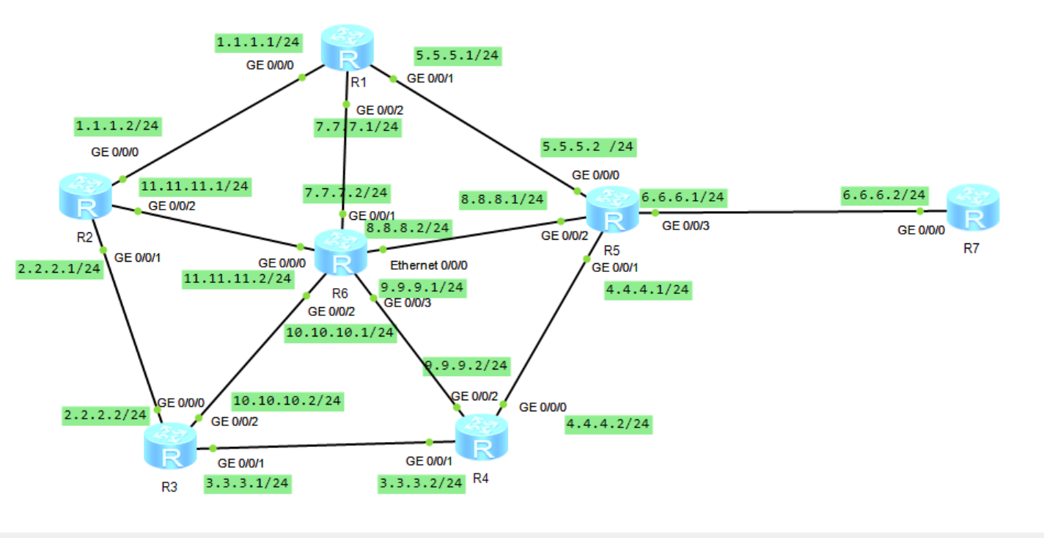

First, we assign the IP address to all connected interfaces of each router and then we configure rip version 2 on all routers.

**CONFIGURATIONS:**

**R1:**

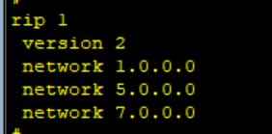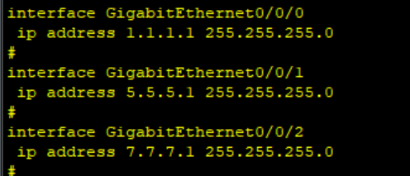

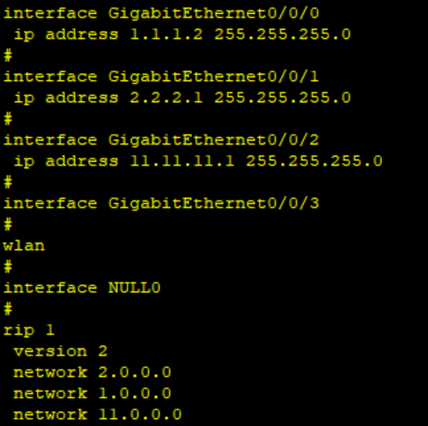**R2:**

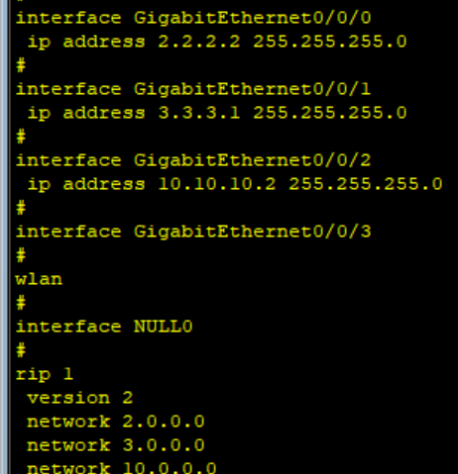**R3:**

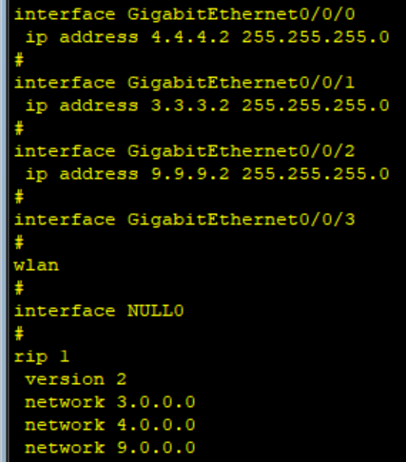**R4:**

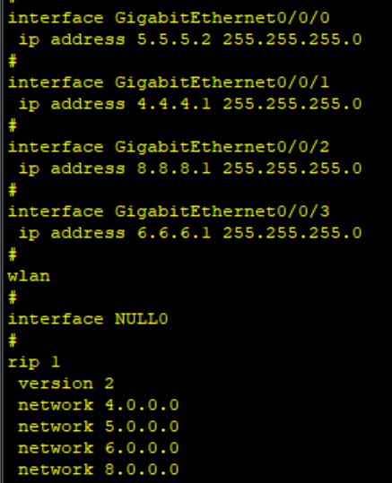**R5:**

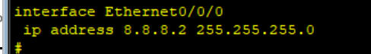**R6:**

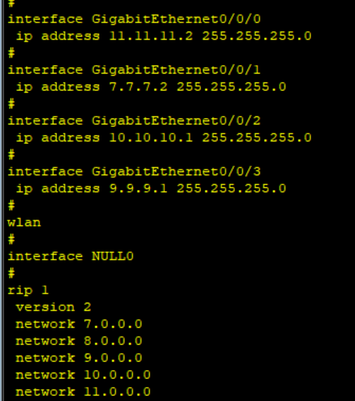

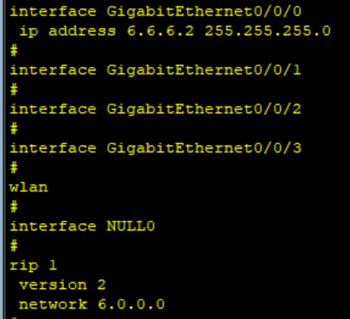**R7:**

**Testing:**

Now we try to ping different networks from a router.

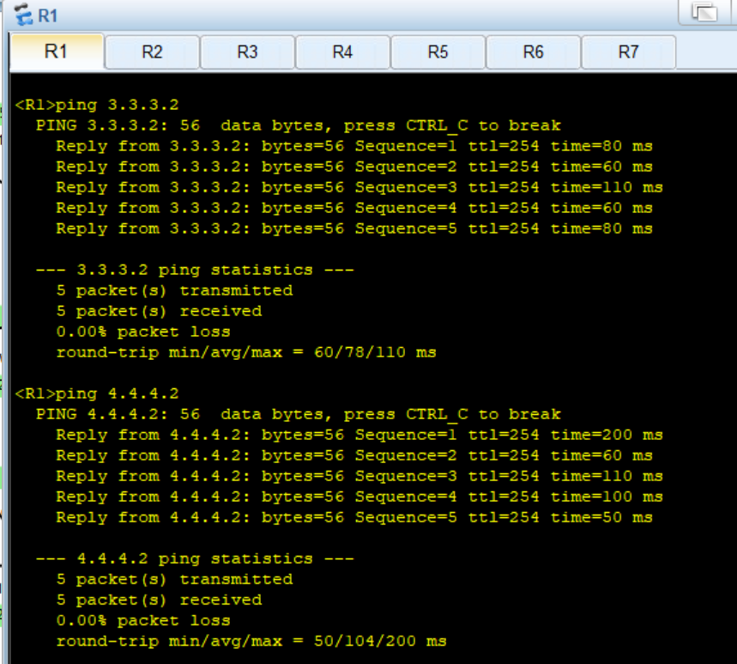**R4 from R1:**

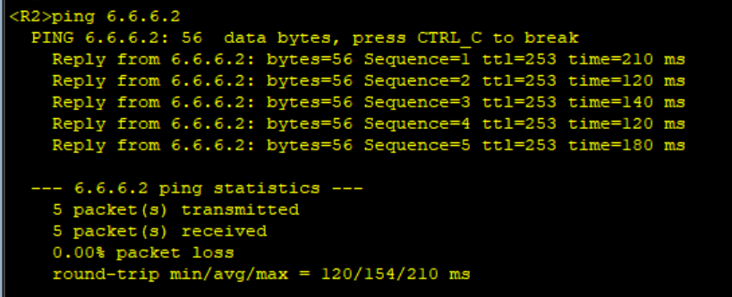**R7 from R2:**

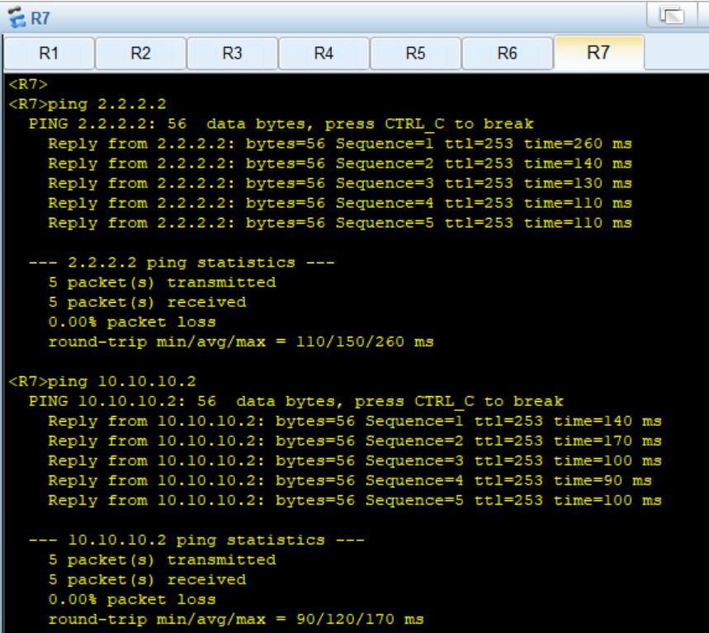**R3 from R7:**

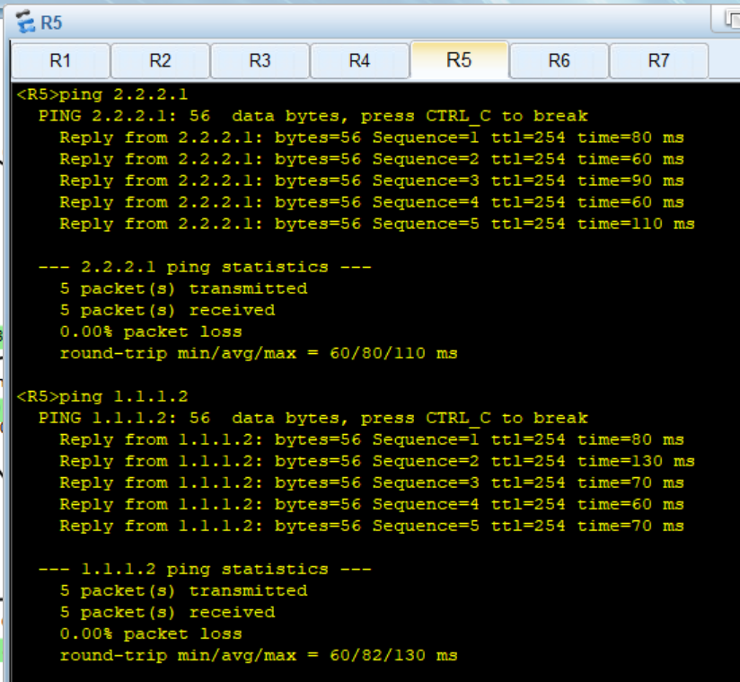**R2 FROM R5:**